Meta title: Digital Platforms Transform Home Care: Connect Caregivers Efficiently
Meta description: Discover how digital platforms can connect caregivers with those who need care, offering transparency, customization, and reduced costs, transforming home care solutions for families.

how digital platforms can connect care givers with those who need care

How Digital Platforms Can Connect Caregivers With Those Who Need Care
![Image Description: A close-up, over-the-shoulder shot of a stressed adult woman sitting in a dimly lit living room at night. She is looking at a smartphone screen which displays a clear, friendly caregiver profile featuring a smiling photo, a "Verified" badge, and a 5-star rating, casting a soft, hopeful glow on her face.]
Most of us have been there: staring at a search bar at 2:00 AM, wondering how we’re going to find a qualified nurse for Mom by Monday morning. For decades, finding home care solutions involved leaving voicemails with agencies and hoping for a callback. Today, the process looks a lot more like the apps already on your phone, offering immediate access rather than waiting games.
Think of these new tools as a specialized digital meeting place. Just as you might browse listings for a vacation rental, you can now view detailed profiles to see exactly how these platforms connect caregivers with those who need care. This shift removes the mysterious "middleman," allowing you to vet reviews, rates, and specific skills before you ever make a call.
While technology cannot replace the human touch, it significantly reduces the stress of coordination. Real families have found that a search which once took weeks can now be resolved with a few hours of scrolling. Whether you need full-time support or are looking for the best platforms for finding private respite care, these modern tools are designed to offer transparency and give you back your peace of mind.
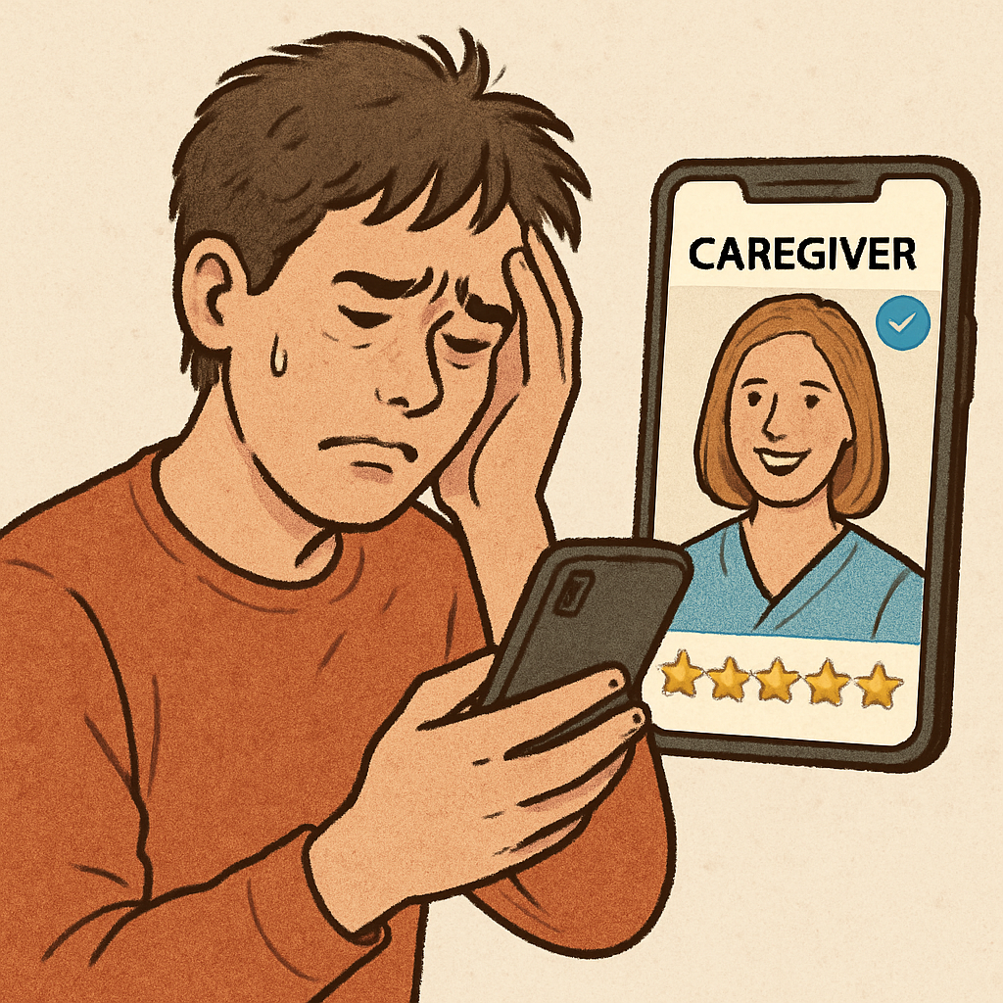

Beyond the Agency: How Digital Marketplaces Put You in the Driver’s Seat
Relying on traditional agencies often means waiting to see who shows up at your door. While leading home care agencies provide excellent oversight, they typically assign a worker based on general availability rather than personality fit. Digital marketplaces flip this script entirely. Instead of simply requesting a service and waiting for a knock on the door, these platforms allow you to browse profiles, read reviews, and hand-pick the specific individual entering your home.
This approach represents the shift from "managed care" to "self-directed care." In the traditional managed model, a case manager handles the logistics and supervision, which is helpful if you are completely overwhelmed. However, self-directed platforms allow you to act as the primary decision-maker. You determine the specific duties and culture fit, offering a level of customization that standard home health care plans often struggle to match.
Financial transparency is perhaps the biggest driver for families making this switch. Premier home health care agencies must charge a premium to cover their overhead, often marking up hourly rates by 30% or more. By connecting directly with workers through a marketplace, that markup disappears. The result is often a higher hourly wage for the caregiver and a significantly lower cost for you, creating a more sustainable financial arrangement for everyone involved.
Taking the reins requires weighing the trade-offs involved in securing non medical home care services. Before choosing a path, consider how the two models compare:
- Cost Control: Marketplaces remove the middleman markup; agencies provide predictable, all-inclusive billing.
- Selection: You interview and hire directly vs. accepting an assigned staff member.
- Back-up Plans: You are responsible for finding replacements if a caregiver cancels; agencies handle call-outs for you.
Once you decide to take control of the hiring process, the next challenge is using technology to filter through hundreds of potential candidates efficiently.

Using 'Smart Sorting' to Find Your Perfect Caregiver Match
Imagine trying to find a needle in a haystack; that is what scrolling through generic classified ads feels like. Modern platforms solve this using digital matching algorithms for senior care to align skills with your specific family dynamic. This process isn't just about finding a warm body to fill a shift, but ensuring the person walking through the door understands your unique situation. If your father loves history but needs mobility support, these smart tools help you find a companion who can handle the physical transfer while engaging in the conversation he craves.
Selecting the right filters transforms a chaotic search into a targeted shortlist. Most platforms allow you to toggle specific requirements, such as a valid home care aide certification or experience with post-operative recovery. This precision is critical when utilizing AI-powered matching for specialized dementia care, as general experience often isn't enough for complex memory-related conditions. By specifying these medical nuances upfront, you save hours of interviewing candidates who simply aren't qualified for the level of support your loved one requires.
Scheduling logistics are often the final hurdle that breaks a promising match. Unlike agencies that might promise coverage without specifics, digital tools let you view real-time calendars to see who is actually free, whether for brief respite or 24 hour home care services. Seeing availability instantly prevents the heartbreak of finding the perfect caregiver only to realize their schedule clashes with yours. Once you identify a candidate who fits your medical needs and timeline, the focus must shift to ensuring they are safe to bring into your home.
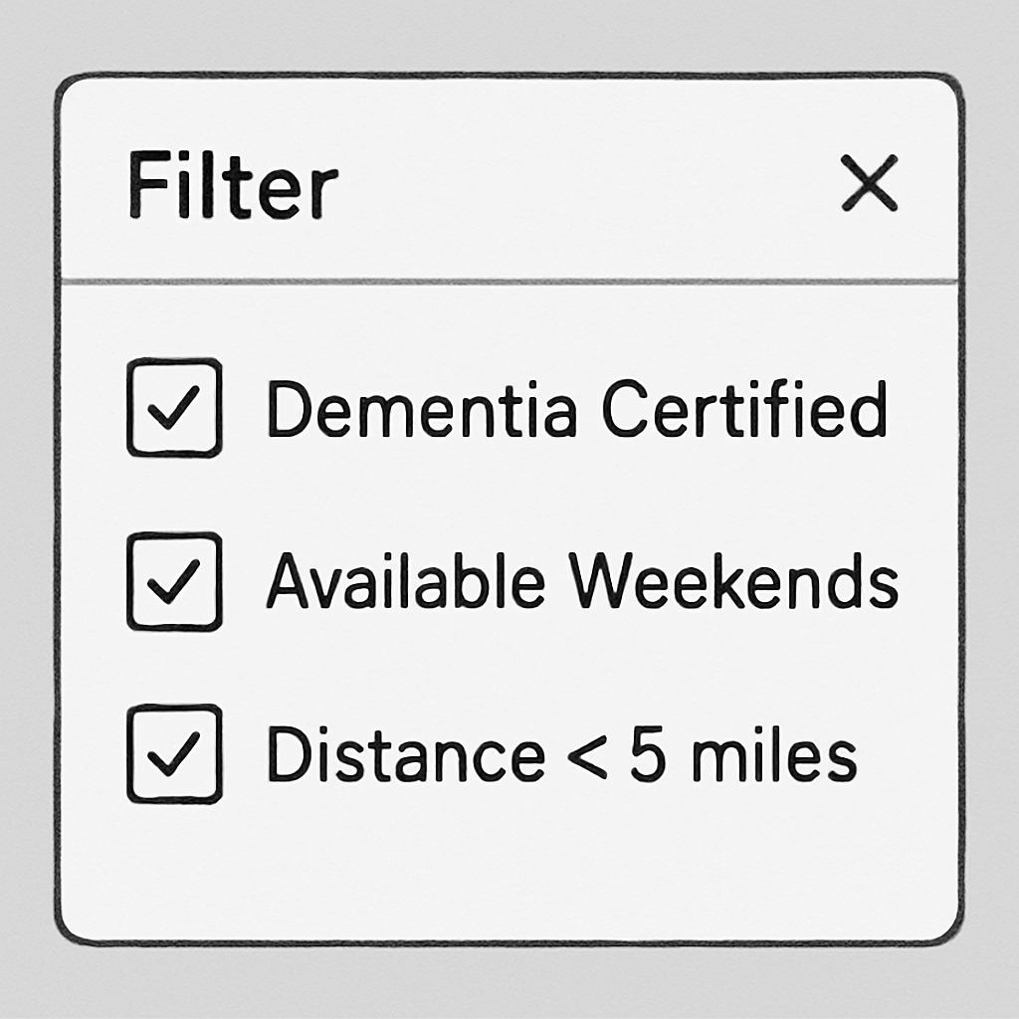

The Safety Check: How to Vet an Independent Caregiver Without a Private Investigator
Finding a profile that looks perfect on paper is a great start, but trust is earned through transparency. Unlike relying on a single neighbor's recommendation, evaluating the quality of online care networks allows you to see feedback from dozens of families who have been in your shoes. Look specifically for "Verified Reviews"—testimonials linked to actual completed bookings—to ensure the praise is genuine. The benefits of user-driven caregiver rating systems lie in the details; a generic five-star rating is nice, but a specific comment mentioning how a caregiver handled a difficult sundowning episode provides the evidence you actually need.
While reviews reveal personality, objective screenings handle the safety basics. Most reputable platforms run preliminary criminal history and identity scans, but you need to know what to look for in a caregiver background check to understand the results. These digital checks typically cover national criminal databases and sex offender registries, acting as a crucial filter. Think of the platform's check as a safety net: it catches the obvious risks, but you still need to verify the person fits your specific home environment.
Before scheduling a home visit, vetting independent caregivers online involves a few final confirmation steps. A quick 10-minute "chemistry check" over video chat can reveal more about a candidate's communication style than their resume ever could. As you review profiles and prepare for that call, watch for these three "green flags":
- Responsiveness: Do they reply to messages within 24 hours?
- Recency: Is their "Last Active" date within the past week?
- Consistency: Do their spoken answers match their written credentials?
Once you have confirmed safety and fit, the conversation naturally turns to the budget. Fortunately, removing the agency middleman often results in significant financial relief.

Cutting the Bill: How Direct-Hire Platforms Can Lower Your 24/7 Care Costs
When calculating monthly 24/7 in-home care costs, the total often exceeds $15,000 due to agency markups that cover corporate overhead rather than the caregiver's wage. By connecting you directly with workers, reducing caregiving costs through direct-hire websites becomes a math problem that finally works in your favor. Families can often unlock savings of 20% to 30% simply because they stop paying for an agency's administrative fees, a crucial difference when budgeting for expensive necessities like specialized in home dementia care costs.
Handling payments directly might feel risky, but modern platforms act as a digital buffer that professionalizes the transaction. Instead of worrying about tax laws or liability issues, these apps use integrated payroll systems to handle withholdings and insurance automatically. You get the financial benefit of a direct hire with the administrative protection of an HR department, ensuring you stay compliant without needing an accounting degree.
Technology also saves money through flexibility that rigid contracts rarely permit. Rather than committing to minimum weekly blocks, you can utilize on-demand healthcare staffing for elderly support specifically when you need a break. This "pay-as-you-go" approach prevents the burnout that often leads to expensive emergency interventions later. Once the finances are streamlined, the challenge shifts to managing the daily logistics of your new team.

From Crisis to Coordination: Using Apps to Sync Your Family’s Care Plan
Managing the budget is only half the battle; knowing what is happening inside the home while you are at work is the other. If you currently rely on a chaotic family group text or a handwritten notebook on the kitchen counter, you know the anxiety of wondering if a task was actually completed. In-home care apps for family coordination solve this by acting as a shared digital dashboard, replacing scattered messages with a single, real-time source of truth.
This visibility essentially functions as remote patient monitoring for aging in place, giving you eyes on the situation without hovering over the caregiver. Modern platforms equip your care team with mobile tools for tracking daily care activities, allowing them to log updates that instantly sync for every family member. Common features include:
- Medication logs to confirm doses weren't missed.
- Meal tracking to ensure proper hydration and nutrition.
- Incident reporting for immediate alerts regarding mood changes or falls.
Security is just as critical as convenience when sharing these sensitive health details. While texting feels easy, using HIPAA-compliant family communication platforms ensures that private medical history stays protected behind bank-level encryption. These secure channels keep everyone on the same page legally and logistically, creating a stable foundation for the team. With the communication lines finally open and secure, you are ready to tackle the specific challenges of finding workers with advanced skills.
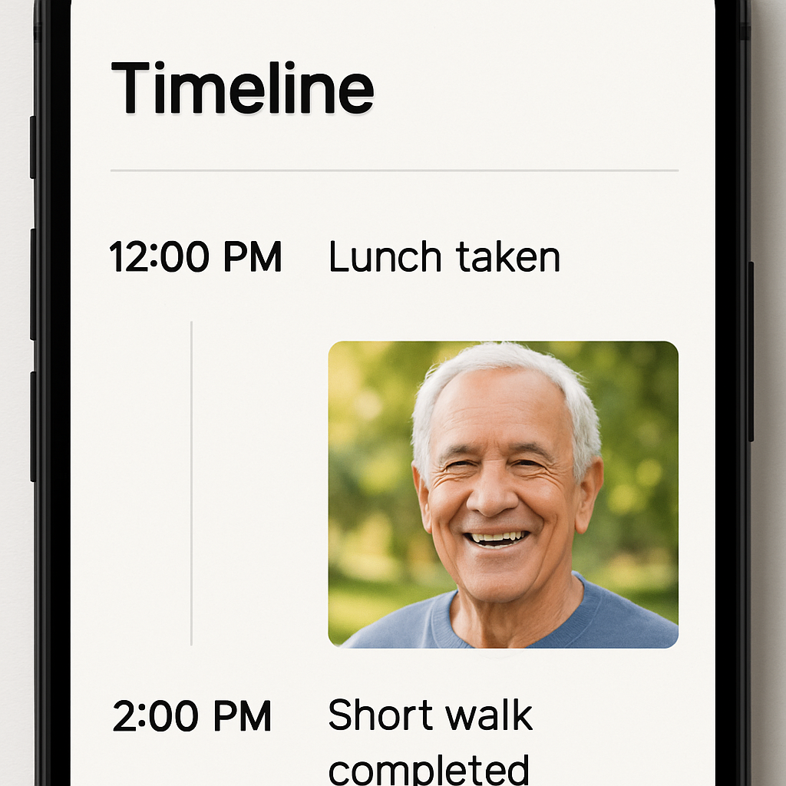

Specialized Support: Dementia and Palliative Care
General job boards might work for finding a companion to play cards with, but when a loved one faces a complex diagnosis like Parkinson’s or Alzheimer’s, the stakes change dramatically. Modern platforms address this through advanced filtering, often described as AI-powered matching for specialized dementia care. Instead of reading through hundreds of generic resumes, you can toggle specific "skill tags"—such as experience with sundowning behaviors, feeding tubes, or mobility transfers—to instantly narrow the field to professionals who have actually handled those specific needs before.
Geography often acts as a cruel barrier to quality support, particularly for families seeking palliative care at home in rural areas where specialists are scarce. Digital marketplaces act as a bridge here, expanding your search radius beyond the local bulletin board to find qualified providers willing to travel. By digitizing the search for specialized home care, these tools connect isolated households with a broader network of expertise, ensuring that physical distance does not dictate the quality of comfort your family member receives during their most vulnerable moments.
Algorithms can match credentials, but they cannot predict human chemistry or how a provider handles a sudden stressor. Experienced users of family resource home care platforms recommend booking a paid "trial shift"—a short, three-hour engagement while you are present—to observe the caregiver in action before committing to a full schedule. This "audition" protects your budget and your peace of mind, ensuring the fit is right before you finalize the roster for the upcoming week.

Your Weekend Roadmap: 3 Steps to Finding Support by Monday
Finding support for a loved one no longer requires endless phone tag or blind trust. With a clear view of how digital platforms connect caregivers with those who need care, you have a roadmap to replace stress with strategy. These tools don't replace your judgment; they simply clear the clutter so you can focus on finding valid home care solutions.
The 'Monday Ready' Checklist:
- Create Your Profile: Be detailed about specific medical needs and personality traits to attract the right matches.
- Set Your Filters: Narrow your search by schedule, budget, and required certifications.
- Schedule 3 Video Intros: Use these digital "chemistry checks" to vet candidates before inviting anyone into your home.
The technology is the bridge, but the peace of mind comes from knowing you are finally in control. Trust the process to find the best home care, use the tools to handle the logistics, and take that first step toward a balanced life today.

